<Landing Page>

<Section 1>

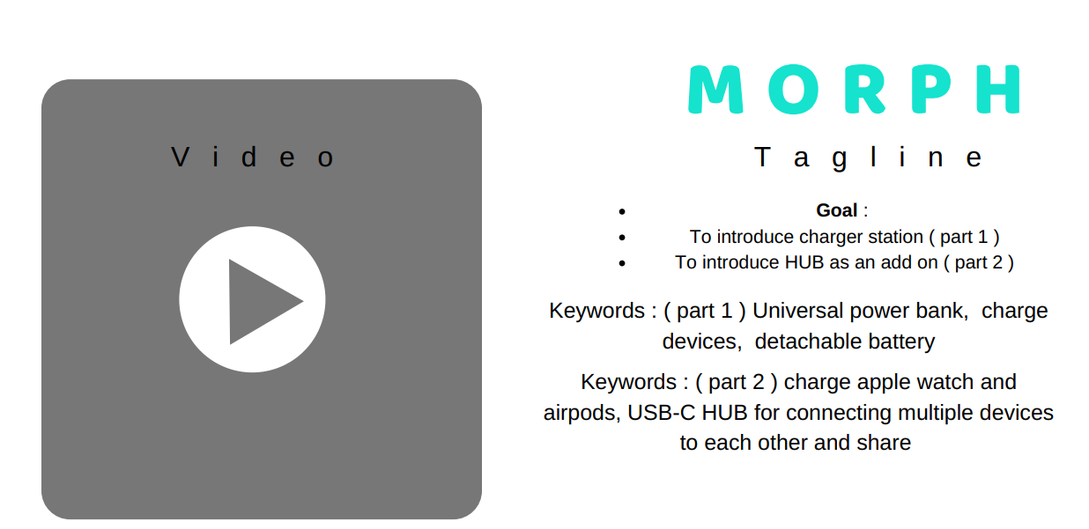

# MORPH

Unlimited Power. For the Relentless You.

Universal Power Bank | Data Transfer Hub | Modular Design| Smart Inside-Out

<Section 2>

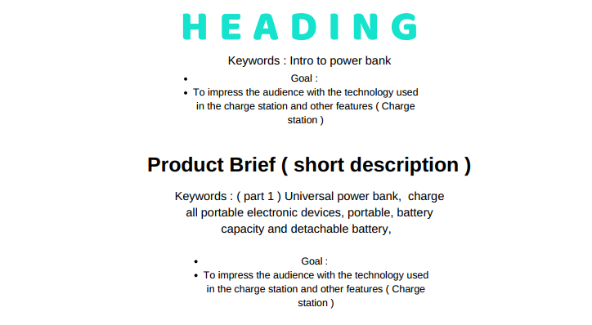

## Innovation Meets Raw Power

MORPH is the ultimate travel companion of the everyday heroes. It’s the most feature-rich portable charger designed for those of us for whom 24 hours is not enough. MORPH offers an unmatched supercharging experience that transcends simple power charging needs. The power-packed 20,400mAh capacity, detachable batteries, data transfer hub addon, smart technology, and a versatile set of ports meet your every power need.

<Section 3>

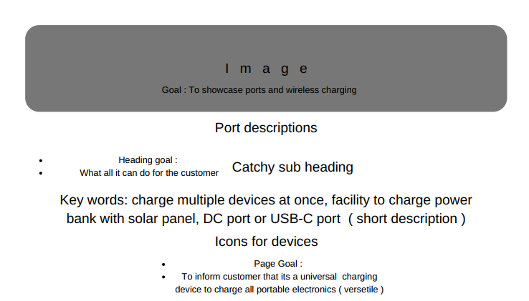

## One Power Source to Run Them All

**Truly All-in-One: Every Type of Port For Every Device**

MORPH is a multipurpose powerplant.

It will keep all your devices alive and working for you non-stop. This is made possible by a full lineup of ports that support a vast variety of devices.

|  |  |
| --- | --- |
| 10W Qi for Wireless Charging | Universal AC Charging Port |
| Fast Charging USB Ports | Apple Watch Charger |
| Power Delivery (PD) Charging Ports | Air-pods Charging Dock |

<Section 4>

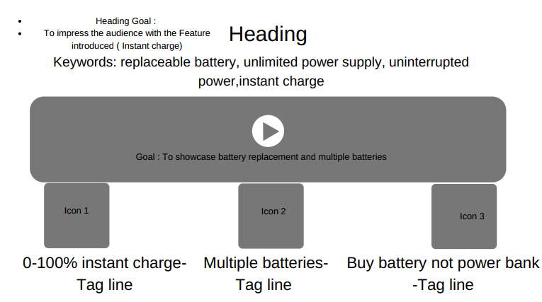

## Seize Complete Control

The most heavy-duty, modular power bank ever created. 20,400mAh capacity supplies enough power to charge multiple devices throughout the day. Innovative modular design makes the unthinkable a delightful reality.

* **Resurrect Instantly from Power Death**

Go 0-100% power bank charge by replacing batteries instead of waiting for a recharge

* **Modular, Efficient, & Cost-effective**

Features 6 removable Li-ion batteries. Replace batteries instead of replacing power bank

* **Unyielding. Just Like You**

Carry spare batteries for extra power. Get endless power supply. Never power down to zero

<Section 5>

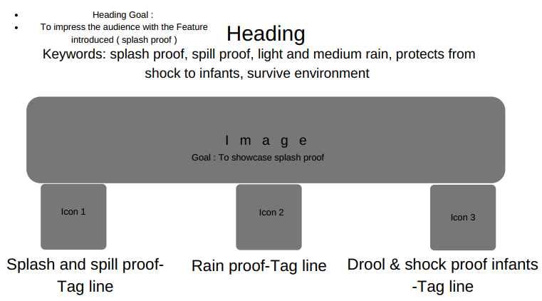

## Born Survivor

The high-performance universal power bank features a rugged body. Its durable construction, high-quality materials, premium design, and matt-gloss finish offer superior protection against Mother Nature and human nature.

* **Splash and Spill Resistant**

Detachable rubber protects the electronic device from common liquid spills, splashes, and even your baby’s drools

* **Sunshine or Rain, Shine On**

Heat, light, or rain – MORPH is engineered to survive a bevy of harsh environments.

* **Shock-proof. Built for Adventure**

No movable parts. Polycarbonate shells offer shock protection against drops and small accidents

<Section 6>

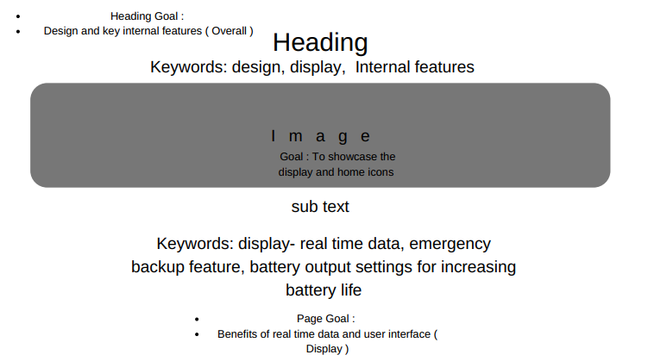

## Intuitive and User-friendly Display

Get real-time data on the power bank’s state – battery charge status, port-level consumption, overload fault notification, HUB power status, and more. Set power reserve as per convenience, configure the battery utilization scheme to extend battery life, and do much more.

<Section 7>

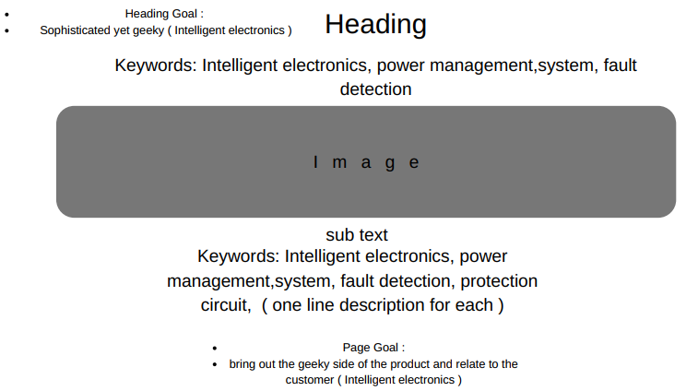

## Enhanced Protection Against Mishaps

The integrated smart power management system offers cutting-edge features. The fault-protection systems protect against power-related mishaps like overloading, overvoltage, overcharging, over-current supply, and charge drain. Intelligent battery management conserves battery power and prolongs battery life.

<Section 8>

## USB-C HUB

**Connect Everything Type-C and More**

The lightning fast 40GB/s USB Type-C Port HUB offers PD Charging and Data Transfer capabilities in one seamless device.

* Charge Apple Watch With Dedicated Charger Outlet
* Charge Apple Airpods With Docking Slot
* Connect and charge multiple devices simultaneously
* Share data between multiple devices
* Features Micro SD Card Slot, SD Card Slot, HSB !3.1 Ports, and HDMI port

<Section 9>

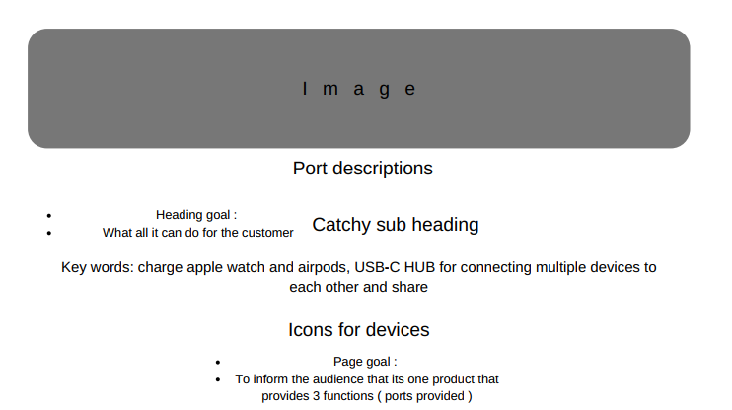

## Elevate Your Experience With Advanced Ports

**Pass-Through Charging | DC & AC Ports | Innovative In & Out Ports**

Charge your devices even as you recharge your power bank. Recharge your universal power bank anywhere in the world using solar panels and get instant recharge. Share data even as you share power between the devices.

**MORPH**

**Experience True Limitless Power**